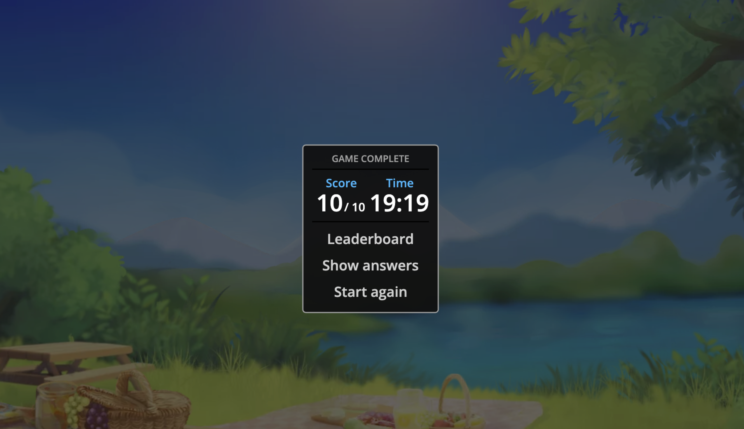

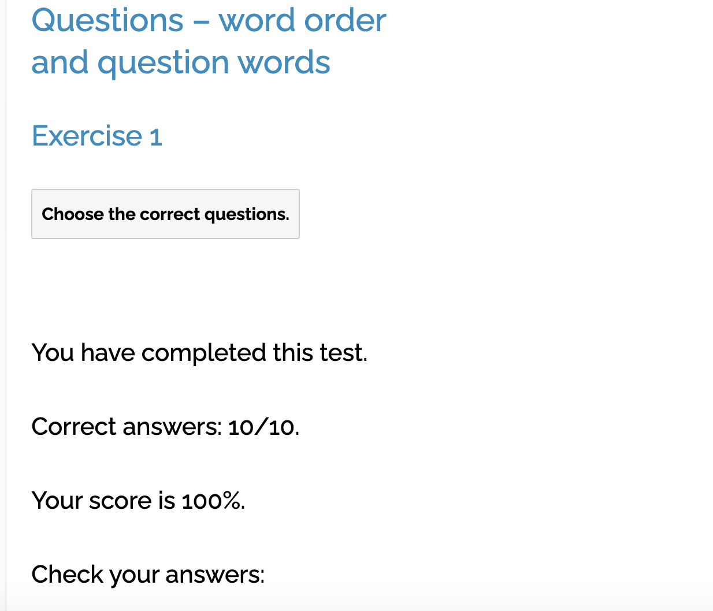

1. **Are you a student**?
2. I’m a student.

1. **Whom do you live** with?
2. I live with my friend Olha.

1. **How often do you go to the cinema**?
2. We go to the cinema about once a week.

1. **When do you start to learn English**?
2. I started learning English when I was at school.

1. **Why do you study English**?
2. I’m studying English because I would like to work in this country.

1. **What do you do when you have free time**?
2. In our free time we like to go to the cinema, or go out with friends. We both love reading, too.